AI-Assistant coding 20.3
ADHI RISHWANTH
2303A52379
BATCH-42
Task 1 – Password Strength & Validation Check
PROMPT: Password Strength & Validation Check
# Requirements:
# 1. Create a function to check the strength of a password based on the following criteria
# - Minimum length of 8 characters.
# - Contains at least one uppercase letter.
# - Contains at least one lowercase letter.
# - Contains at least one digit.
# 2. The function should return a message indicating whether the password is "Strong", "Moderate", or "Weak".
# 3. Handle edge cases (e.g., empty string, only special characters) appropriately
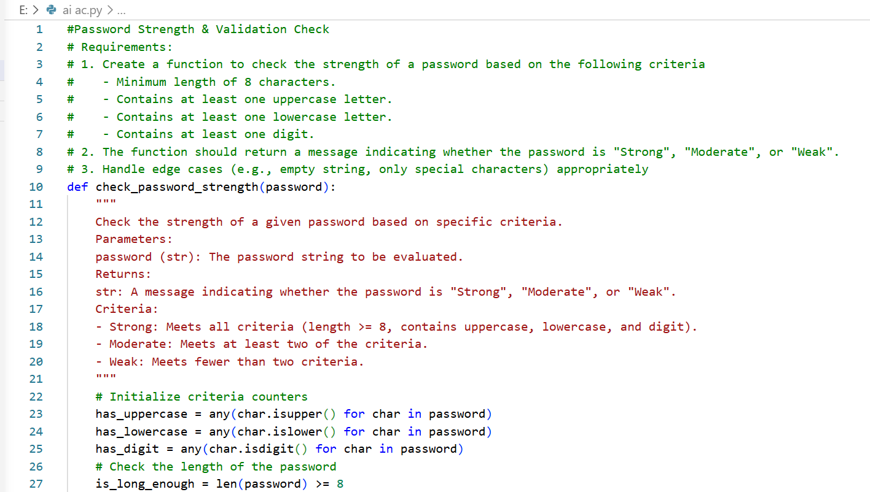
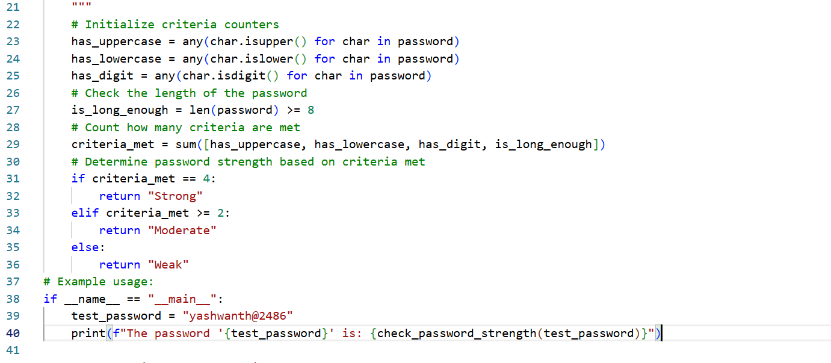
OUTPUT:
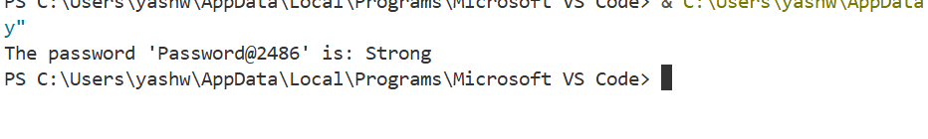
Task 2 – Insecure File Upload Handling
PROMPT: # Requirements:
# 1. Create a function to handle file uploads securely.
# 2. Validate the file type (e.g., only allow .jpg, .png, .pdf).
# 3. Check the file size (e.g., limit to 5MB).
# 4. Sanitize the file name to prevent directory traversal attacks.
# 5. Store the file in a designated directory with a unique name to avoid overwriting
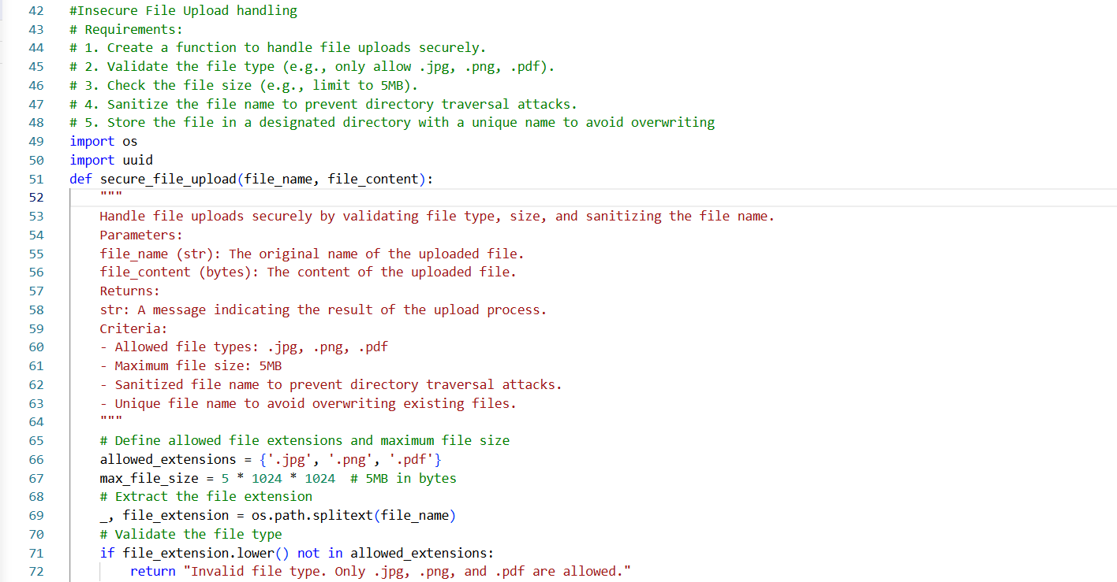
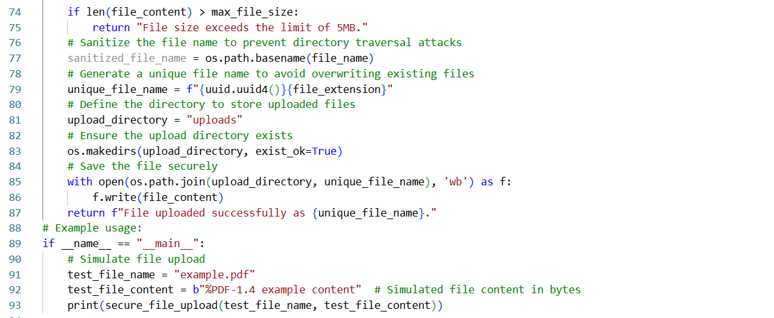
OUTPUT:
Task 3 – Real-Time Application: API Security Review
# Requirements:
# 1. Create a function to review API security based on common vulnerabilities.
# 2. Check for vulnerabilities such as:
# - SQL Injection
# - Cross-Site Scripting (XSS)
# - Insecure Direct Object References (IDOR)
# 3. The function should return a report indicating the presence of any vulnerabilities and recommendations for mitigation
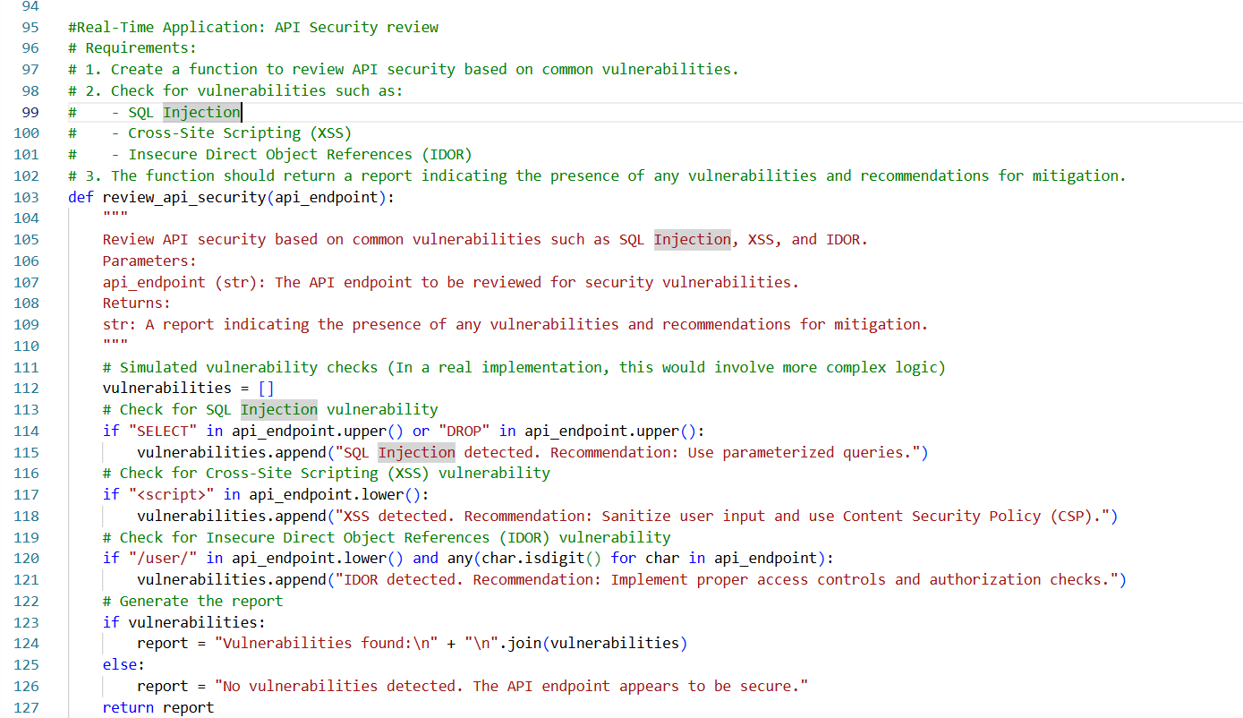
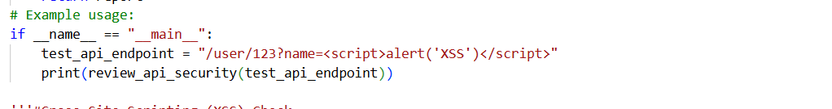
OUTPUT:
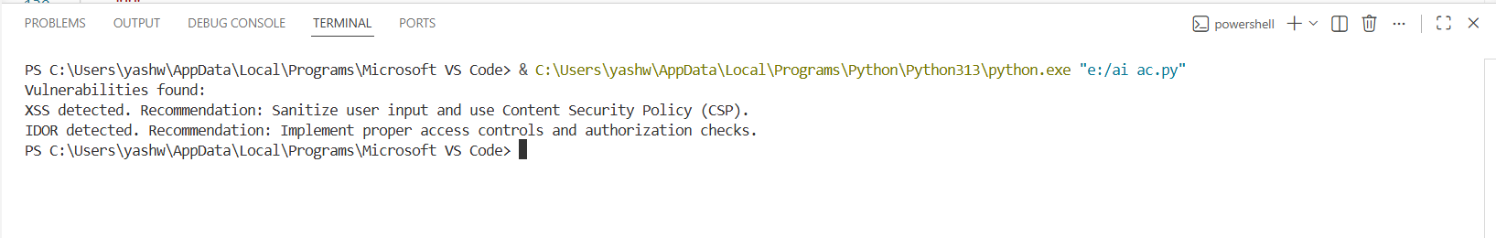
Task 4 – Cross-Site Scripting (XSS) Check
PROMPT: Requirements:
# 1. Create a function to check for potential XSS vulnerabilities in user input.
# 2. The function should analyze the input for common XSS attack vectors (e.g., <script> tags, event handlers).
# 3. The function should return a message indicating whether the input is safe or potentially vulnerable to XSS attacks
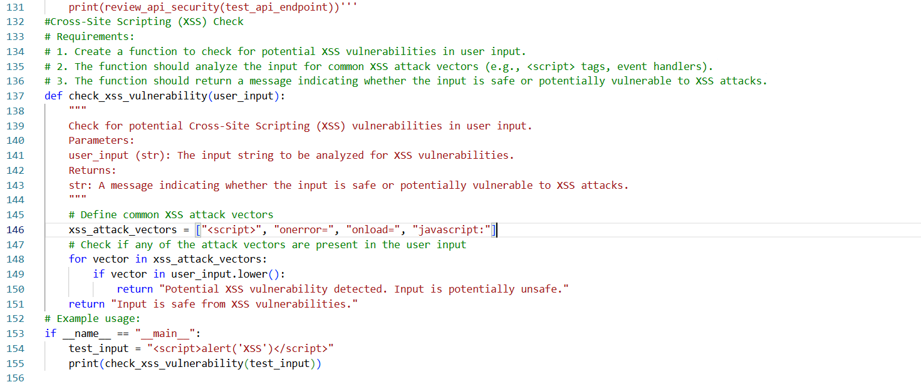
OUTPUT:
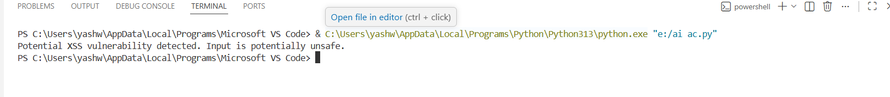
Task 5 – SQL Injection Prevention
PROMPT: Requirements:
# 1. Create a function to prevent SQL injection attacks by sanitizing user input.
# 2. The function should escape special characters and use parameterized queries
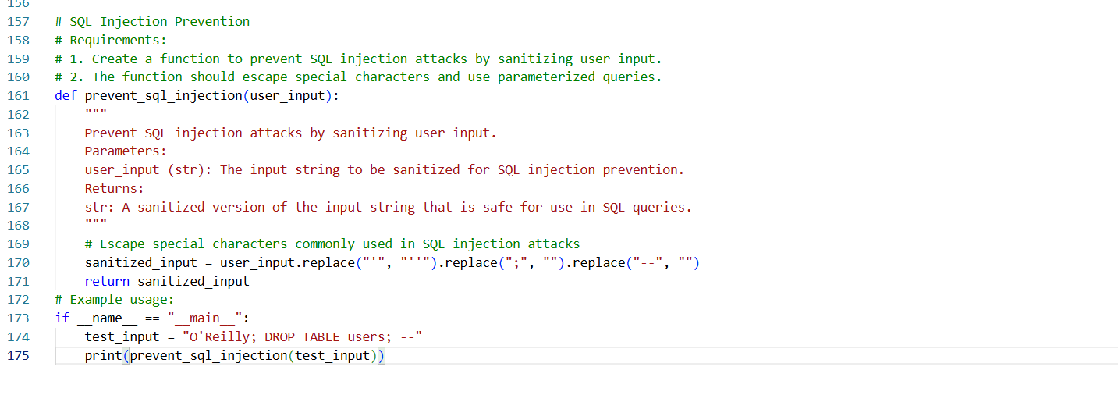
OUTPUT:
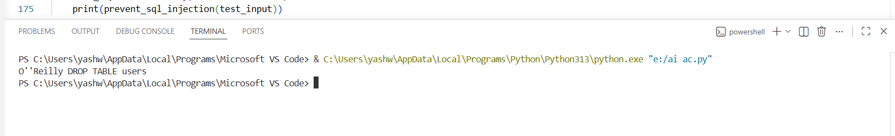

AI_AC 20.3
2303A52432
BATCH-42
Task 1 – Password Strength & Validation Check
PROMPT: Password Strength & Validation Check
# Requirements:
# 1. Create a function to check the strength of a password based on the following criteria
# - Minimum length of 8 characters.
# - Contains at least one uppercase letter.
# - Contains at least one lowercase letter.
# - Contains at least one digit.
# 2. The function should return a message indicating whether the password is "Strong", "Moderate", or "Weak".
# 3. Handle edge cases (e.g., empty string, only special characters) appropriately


OUTPUT:

Task 2 – Insecure File Upload Handling
PROMPT: # Requirements:
# 1. Create a function to handle file uploads securely.
# 2. Validate the file type (e.g., only allow .jpg, .png, .pdf).
# 3. Check the file size (e.g., limit to 5MB).
# 4. Sanitize the file name to prevent directory traversal attacks.
# 5. Store the file in a designated directory with a unique name to avoid overwriting


OUTPUT:
Task 3 – Real-Time Application: API Security Review
# Requirements:
# 1. Create a function to review API security based on common vulnerabilities.
# 2. Check for vulnerabilities such as:
# - SQL Injection
# - Cross-Site Scripting (XSS)
# - Insecure Direct Object References (IDOR)
# 3. The function should return a report indicating the presence of any vulnerabilities and recommendations for mitigation


OUTPUT:

Task 4 – Cross-Site Scripting (XSS) Check
PROMPT: Requirements:
# 1. Create a function to check for potential XSS vulnerabilities in user input.
# 2. The function should analyze the input for common XSS attack vectors (e.g., <script> tags, event handlers).
# 3. The function should return a message indicating whether the input is safe or potentially vulnerable to XSS attacks

OUTPUT:

Task 5 – SQL Injection Prevention
PROMPT: Requirements:
# 1. Create a function to prevent SQL injection attacks by sanitizing user input.
# 2. The function should escape special characters and use parameterized queries

OUTPUT:


